Tuesday Plan - 5th May 2020:

Daily activities:
Spellings: Learn 4 spellings each day.
Reading: Read for at least 20 minutes.
Tables: Practice your multiplication tables (focus on x9 and x10 this week)
Gaeilge: Practice 5 questions of your choice and answer orally.
Whole-school event: Go to the Well-being Fortnight page for today’s activity!

1. English:
Just like every other week, we are starting with some stations today. This week, we have just 3 stations, as we are adding a new task for you to try, which may take a little more time.
● Station 1: Cursive handwriting - complete the handwriting sheet given. You can print the sheet provided, or write the sentences into your copy. If you wish, you can go to Aisling’s page on our website, where she has made a video which shows you how to form each letter in both lower case and upper case. It is really helpful!
● Station 2: Practise writing out your sixteen spellings using Look, say, cover, write, check. Look up any unfamiliar words.
● Station 3: Log on to the Seesaw app. Here you will see that we have assigned an activity called ‘Introduction to Seesaw tools’. We want you to give it a go! (Note: It says in the activity to upload a photo of yourself. You don’t have to do this. You can take a photo of your work or something else in your home. We just want you to practise uploading a photo on Seesaw!)

2. Maths:
- This week you are going to be learning about area. Take a look at this video which introduces the topic and explains a bit about it.
- Using copies or sheets of paper, cover these items and see how many sheets/ copies it takes for them for them to be fully covered, and write it down: a table, your bed, a towel, a couch.
- Look at/do p. 138 in Planet Maths.

3. History:
- This week, we will be learning about the Aboriginal people in Australia.
- This video explains who the Aboriginal people are.
- Read more about the Aboriginal people here. Answer the questions at the end, either in your copy or orally.

Bonus activity: It is really important to stay active while you are at home. We know that you enjoy the Go Noodle videos at school. They have their own YouTube channel here where you can check out all of their fun dances and exercises.

English:
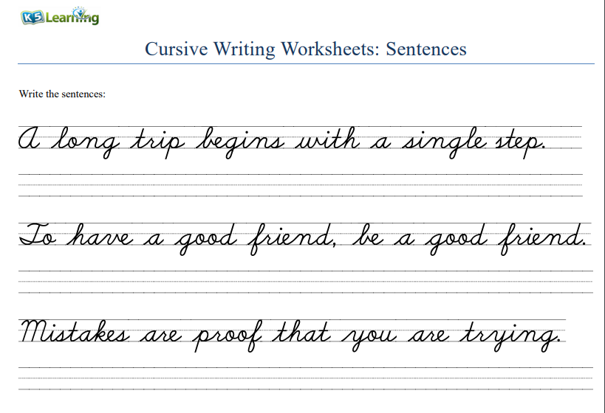
Maths:

