Tuesday
Empower Tools - be kind to yourself
Spellings
Tables ÷4 ÷5
Maths - Decimals
Gaeilge - Éadaí - listen and draw
Science - African Animals
Be kind to yourself
- Spellings: relevant, merchant, brilliant, reluctant, pleasant, restaurant.
Sentences: Put 3 of these spellings into a sentence each.

- Maths:
- Revise ÷4 ÷5 tables. Click Maths Game for another game to help you.
- Today’s goal: adding and subtracting decimal numbers
- Answer A&B on page 110.
- *There are extra maths worksheets for those who would like a challenge under Fridays work*

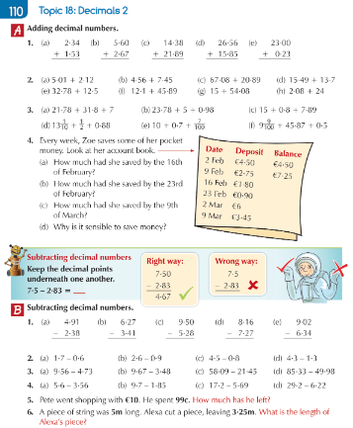

3. Gaeilge (see Gaeilge support document for translations)
- Eist and Tarraing - Listen to the instructions and Draw the clothes
- (https://www.folensonline.ie/home/library/programmes/abair-liom-4th-class/resources/)

Tuesday –
Listen and Draw (draw the childrens clothes)

https://www.folensonline.ie/home/library/programmes/abair-liom-4th-class/resources/

This is the link for the listen and draw activity. If you cannot play it I have written out the transcript here along with translations to correct.

-Tá an teaghlach ag dul go dtí cóisr ghalánta. – The family are going to a fancy party
-Cad atá á chaitheamh ag na páistí? – What are the children wearing?

-Tá Síofra ag caitheamh sciorta fada. – Síofra is wearing a long skirt
-Tá blús geal uirthi – She has a bright blouse on her.
-Tá bróga faiseanta uirthi freisin – She has fashionable shoes on too.

-Tá Oisín ag caitheamh léine ghalánta. – Oisín is wearing a fancy shirt
-Tá bríste dearg air. – He has red trousers on
-Tá bróga donna air freisin. – He has brown shoes on too.

-Tá Seán ag caitheamh culaith ghorm – Seán is wearing a blue suit
-Tá léine bhán air faoin gculaith – He has a white shirt on under the suit
-Tá carbhat dearg air – He has a red tie on
-Tá bróga dubha air freisin – He has black shoes on.

4. Science
Look at this video on African Animals
List as many animals from the film that you can.
Describe the different habitats
Pick one the animals featured and write a fact file with 10 facts about that animal.

