Tuesday:

Suggested Daily Schedule

Spellings: Practice your spellings each day
Maths: Practice Big Maths Beat That each day
Reading: read a book for 30 mins each day
Language: complete your activity for each day (https://www.citywestetns.ie/language-fortnight.html)

Spellings: precede, premiere, precedent, prehistoric, preference, premature
Sentences: Put 3 of these spellings into a sentence each.

Maths
Go to SeeSaw and complete the activity ‘Perimeter’ that is set for today.

Go to Planet Maths page 134 and complete A, B & C

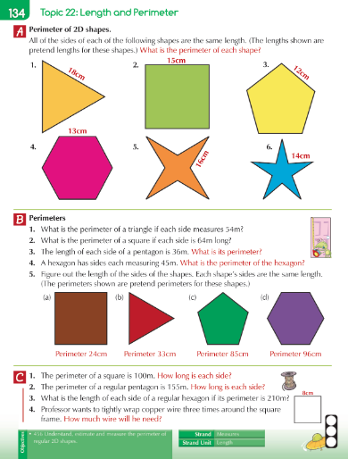

English

Complete the adjectives activity on Seesaw

Science - Magnetism
Watch the video (linked on homepage) on magnetism and complete the ‘Magnetic Attraction’ activity on Seesaw

Language Fortnight
Complete activity for today

