Tuesday

Suggested Daily Schedule

Spellings: learn 6 spellings each day
Maths: Practice Big Maths Beat That each day
Reading: read a book for 30 mins each day
Wellbeing: complete your activity for each day

Bonus Activity- Try make an origami envelope( with a secret message inside) on ‘A message from Emer’ page

Spellings: chemist, cyclist, florist, persist, soloist, specialist,
Sentences: Put 3 of these spellings into a sentence each.

- Maths:
- Go to page 128 in Planet Maths. Complete C (what comes next in the pattern)
- Go to page 129 and complete A,B&C.
- For an extra challenge try this building challenge with lego blocks/cubes/whatever else you have at home. (for more of the challenge cards click the link on the homepage)
- 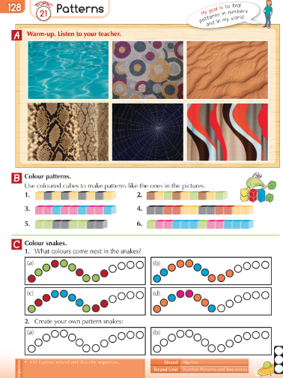
- 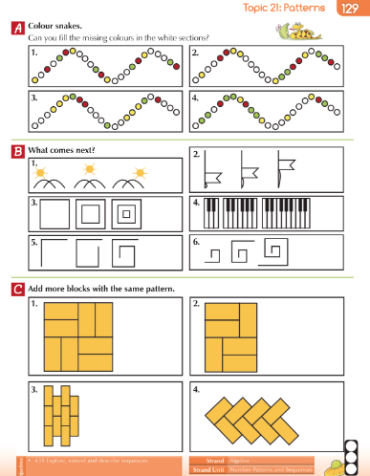
- 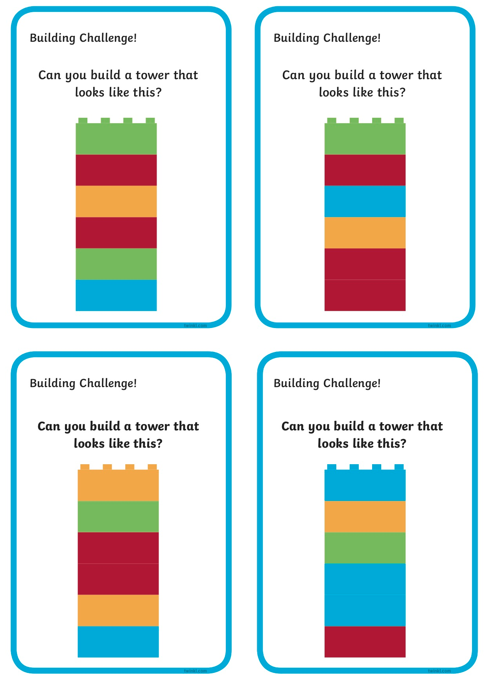
- 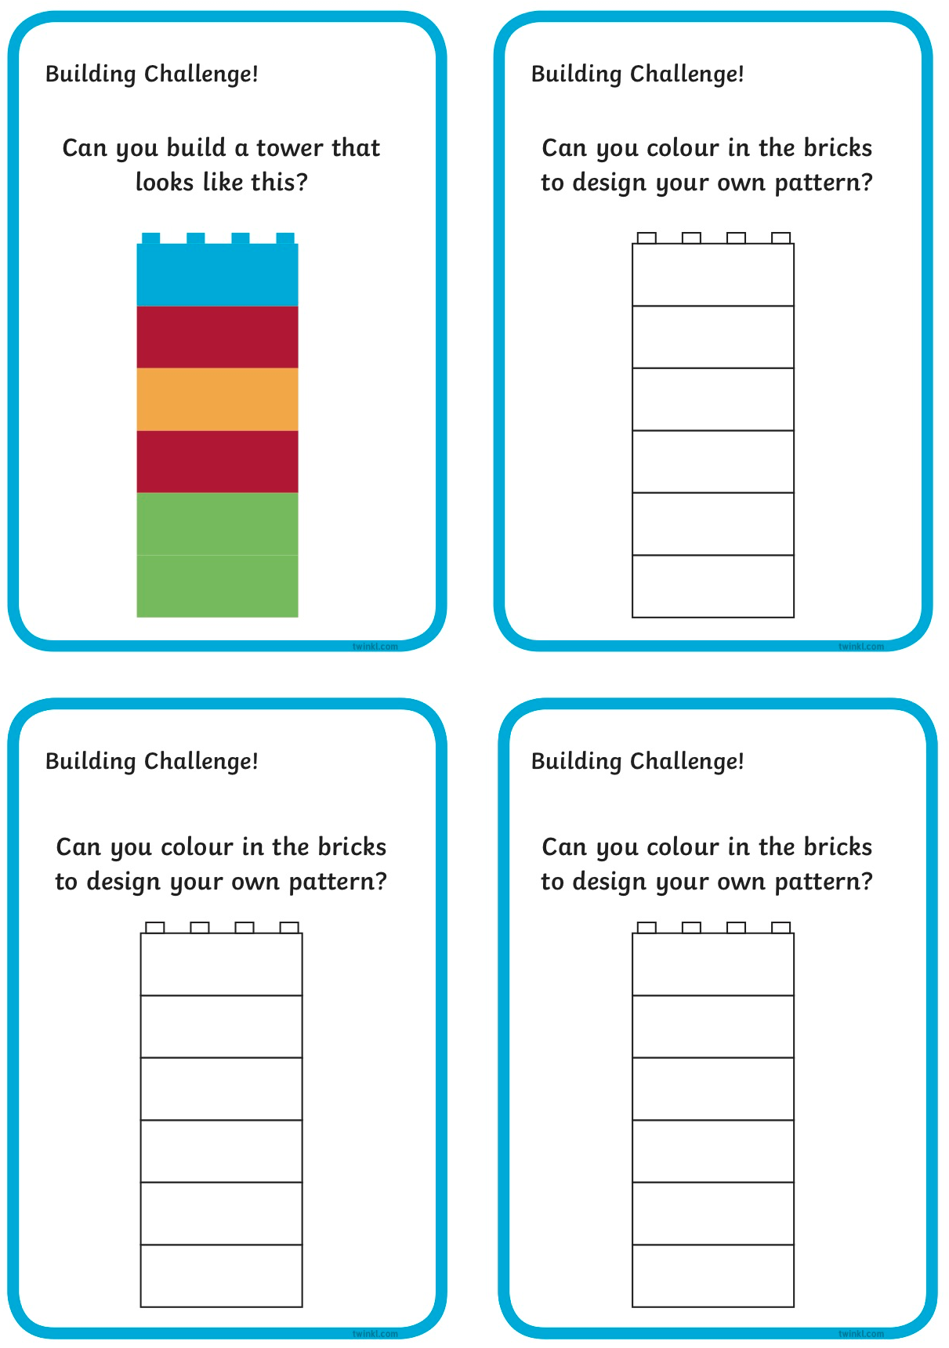

2. English:
This week, we are learning about persuasive writing. Take a look at the video for today, where Orla in 3rd class will introduce the topic to us. Here is a link. There are 2 interactive activities to join in with during this video, so you will need to pause it to allow time to discuss each one. You will be deciding if you agree/disagree with statements and giving some reasons why. You may even want to get your family involved and see if you all have the same opinions!
- Next, you are going to write some reasons as to why you agree/disagree with the statements.

- There should be no homework for children ( try and think of 3 reasons for why you agree and disagree for each statement.)

Reasons for(agree) | Reasons against(disagree)

- Dogs are the best pet to have.

Reasons for | Reasons against

- Football is the best sport.

Reasons for | Reasons against

3. Science - Teeth

Watch the video on teeth and look at the powerpoint presentation. Then answer the questions on the sheet below.

