Thursday

Suggested Daily Schedule

Spellings: learn 6 spellings each day
Maths: Practice Big Maths Beat That each day
Reading: read a book for 30 mins each day
Wellbeing: complete your activity for each day

Bonus Activity- learn to count to 10 in another language using the website duolingo.

Spellings: Revise all spellings and try to find them all in this wordsearch.
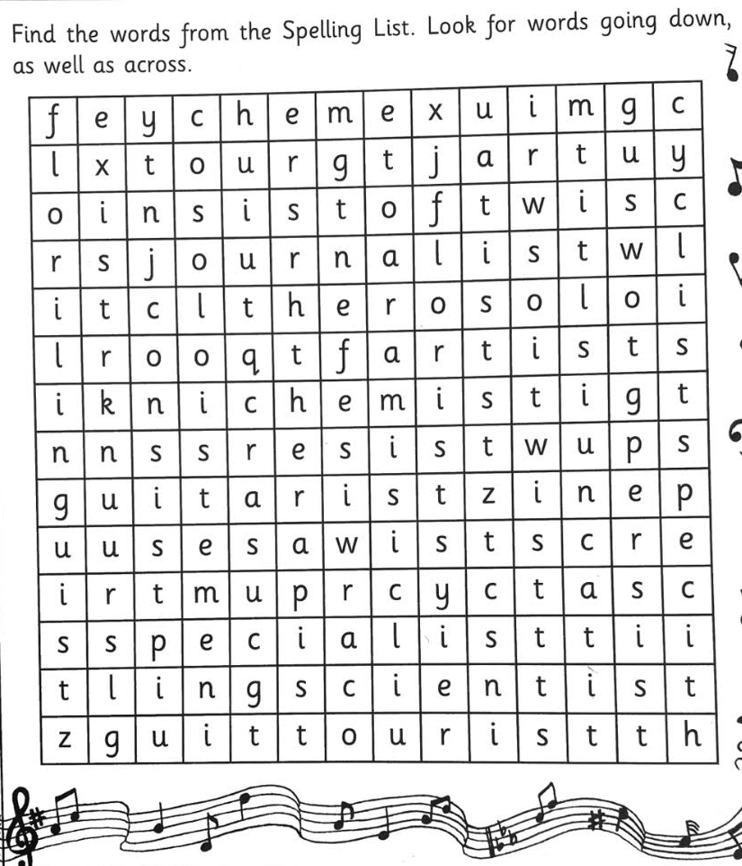

- Maths:
- Go to Page 131 in Planet Maths complete A&B.
- Go to Seesaw and complete the ‘Number Patterns’ activity.
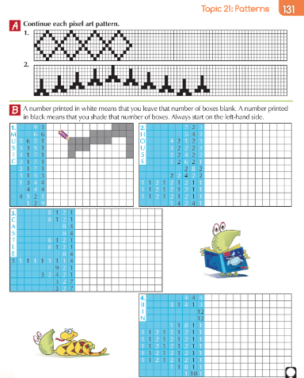
- Science - Teeth. Answer the questions on the sheets below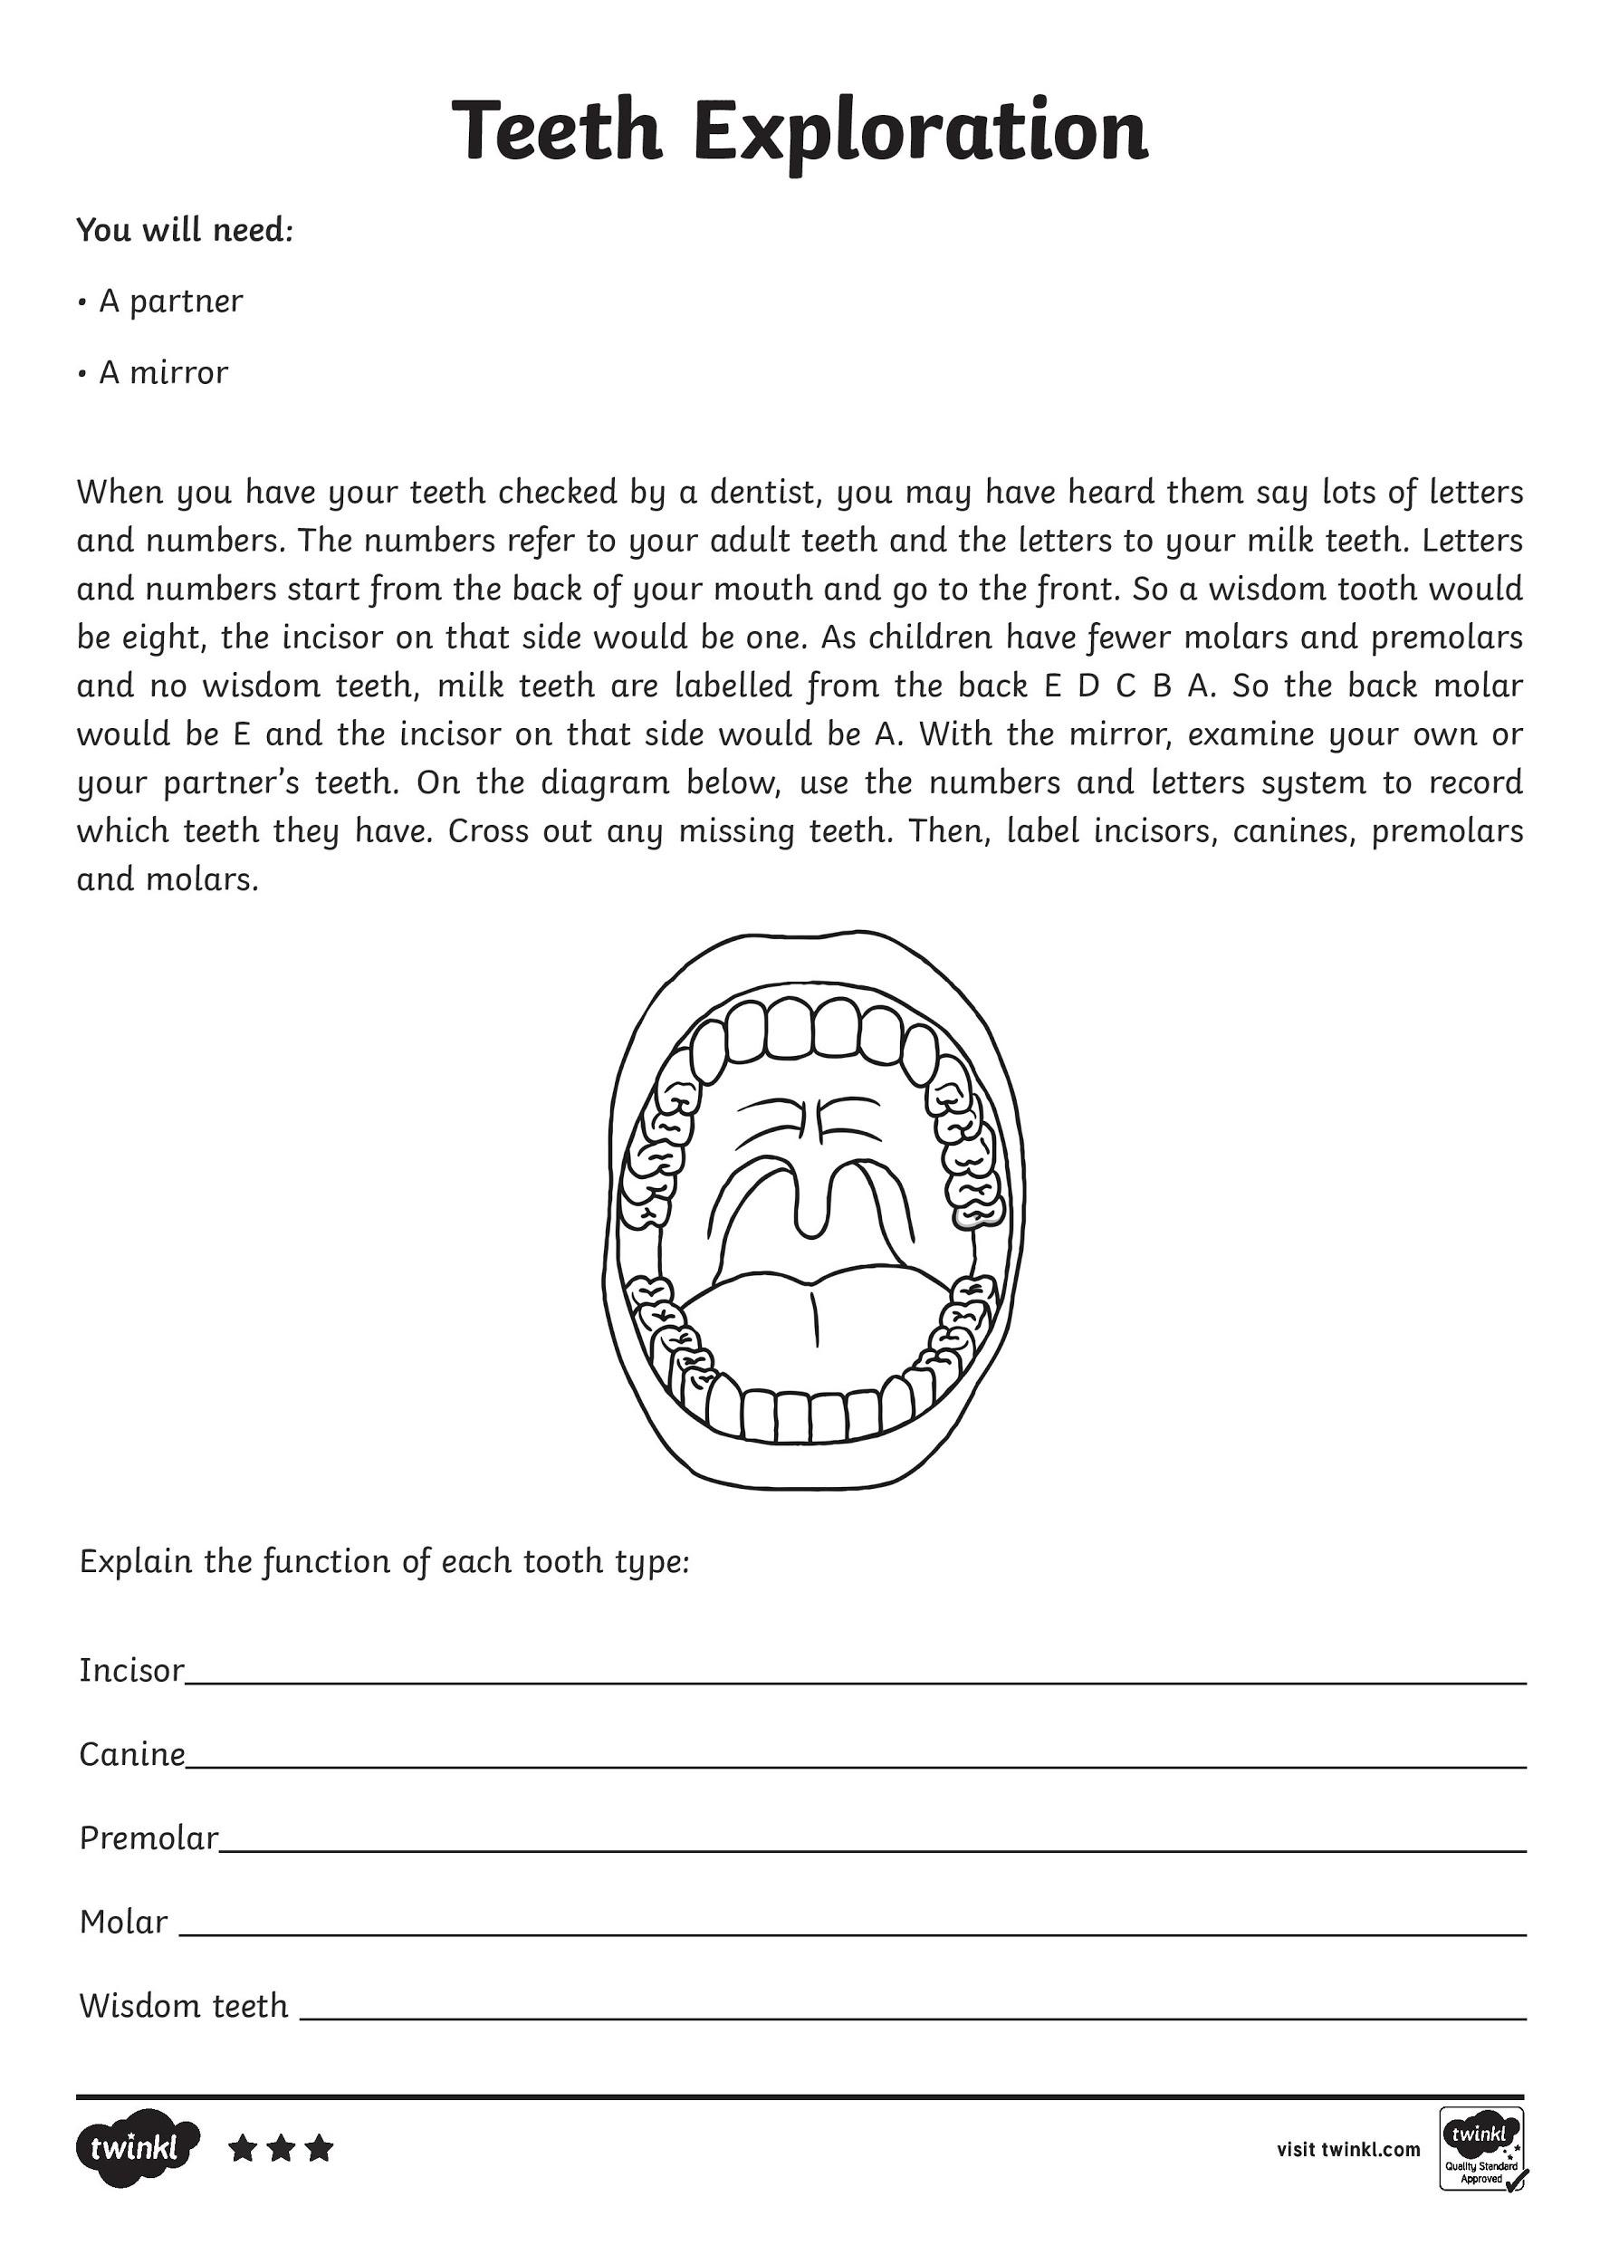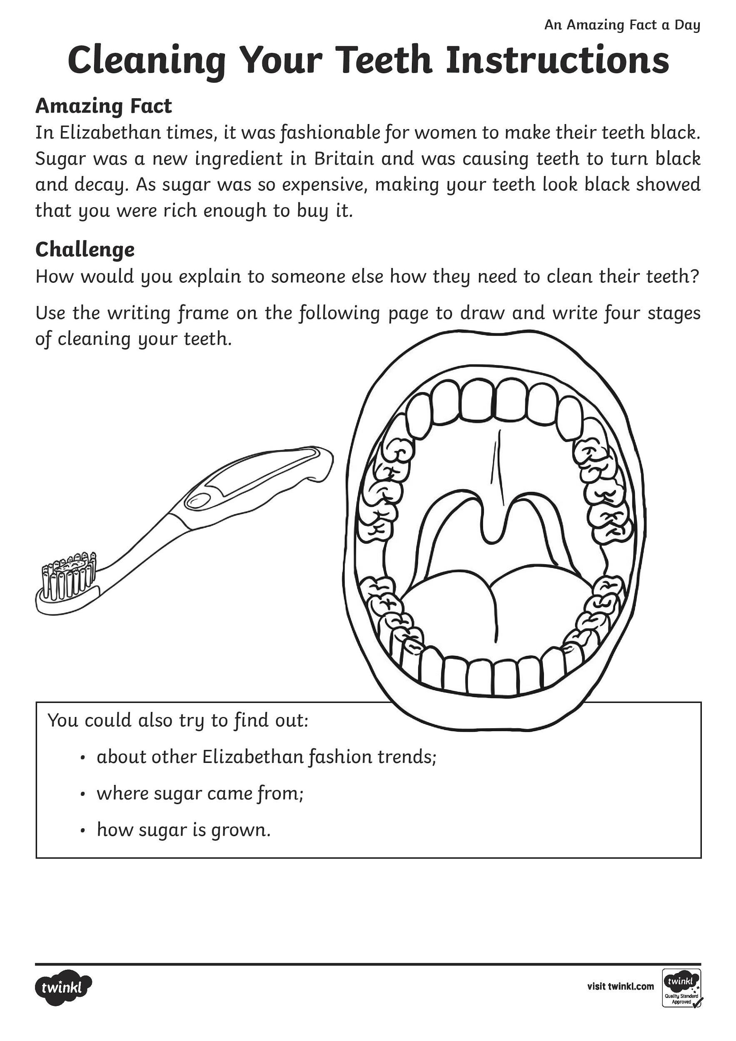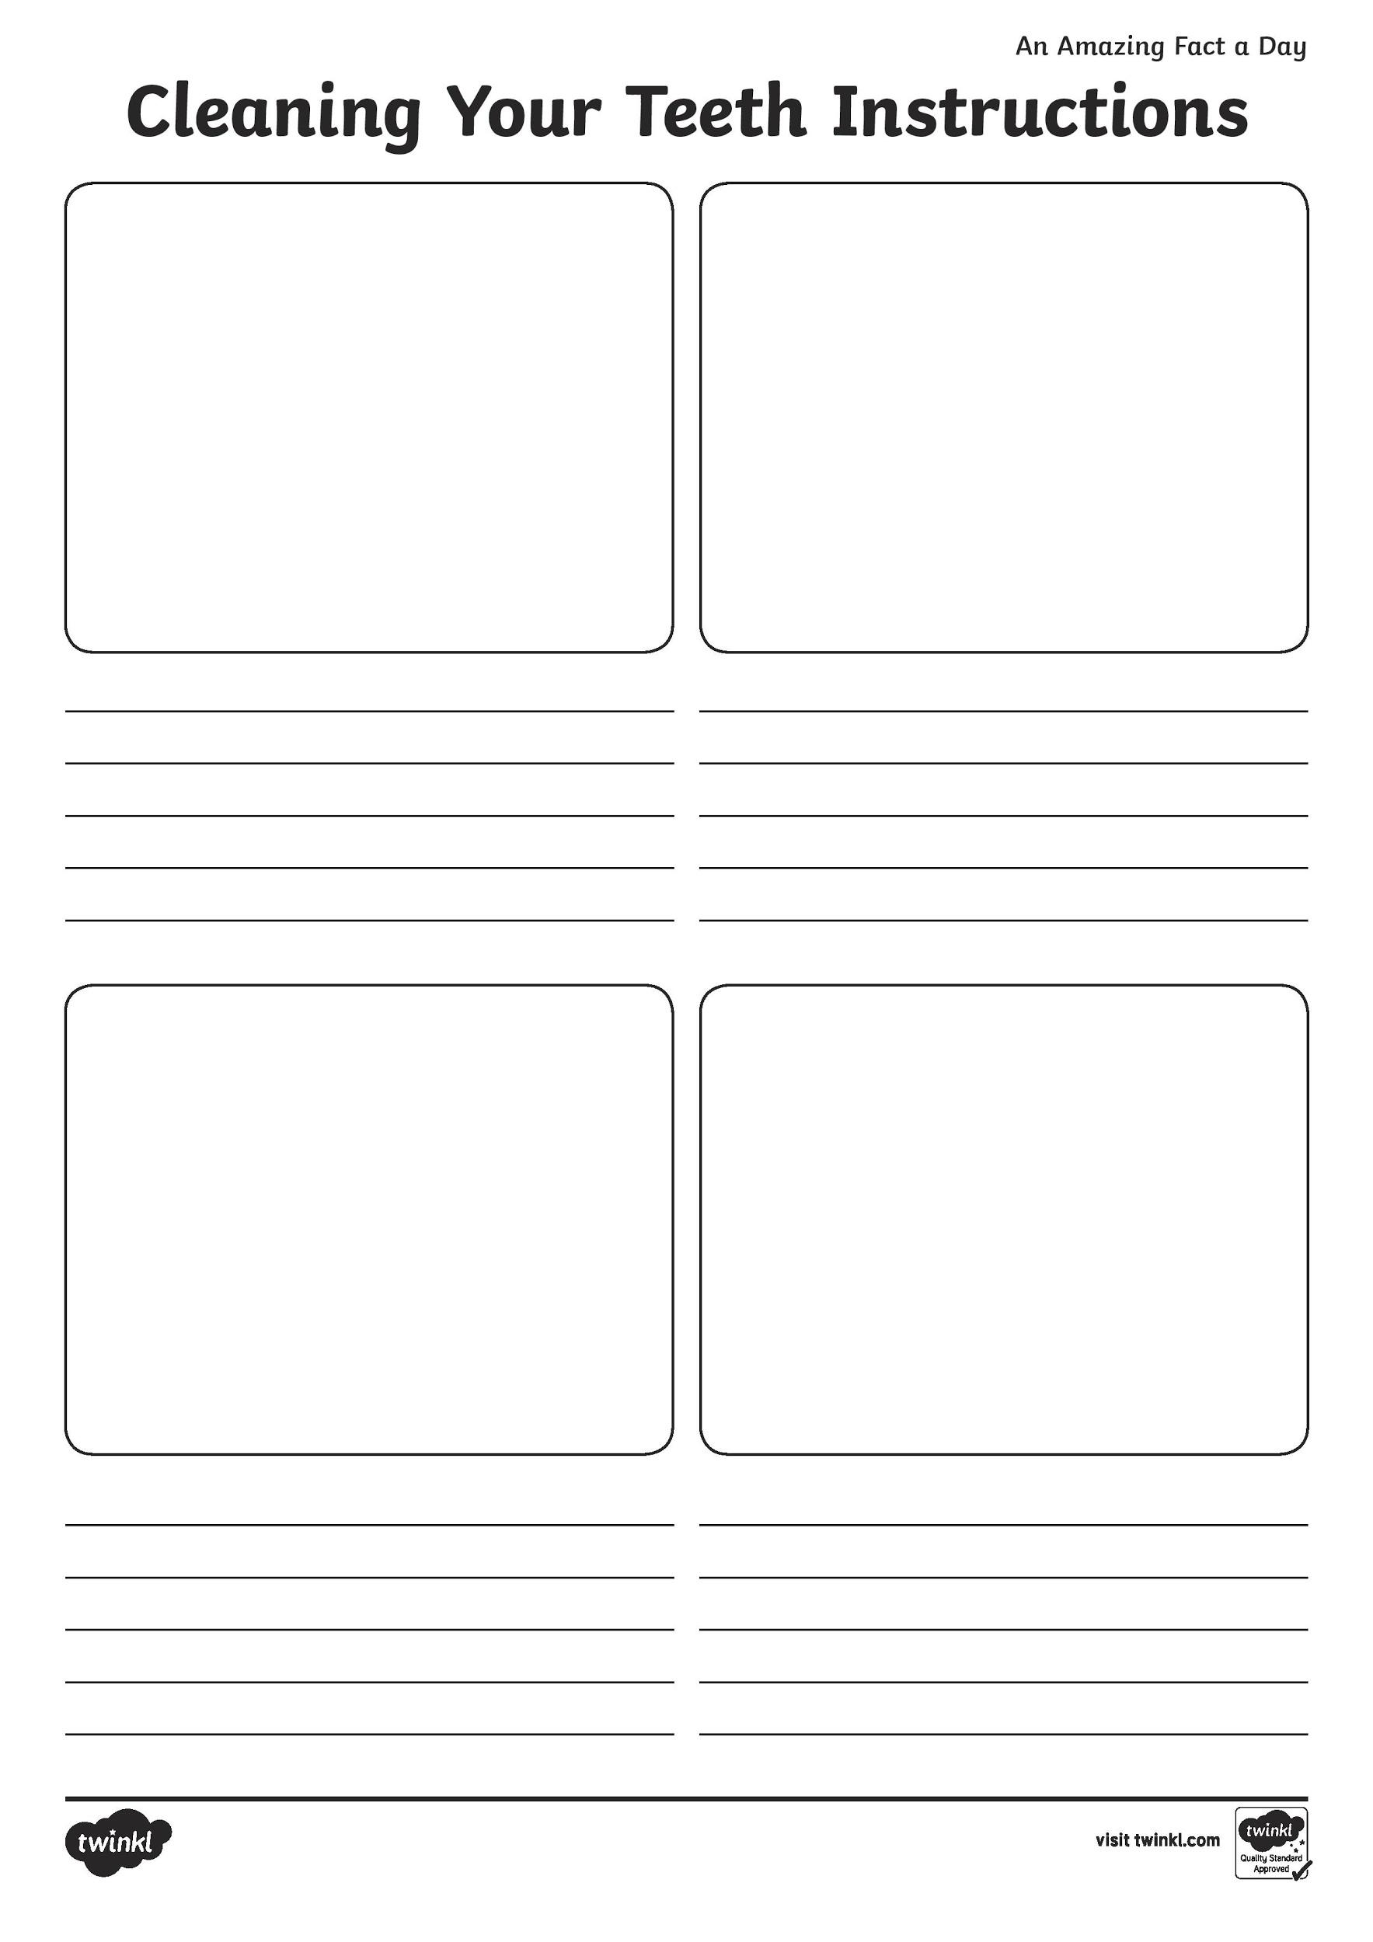
- English

Secret Agent Challenge

Good morning agents!
We at the tourism Ireland department urgently need more people to visit Ireland. Tourism has fallen dramatically.

Your challenge is to deliver a 2 minute passionate speech to potential future tourists, to encourage them back to Ireland (when it is safe for travelling of course).

You need to prepare by researching some reasons for why tourists might want to come to Ireland.

Try and think of 5 good points as to why tourist might want to visit the island of Ireland.
Remember to use positive language to really convince any potential visitors to come to Ireland.

Use this mat below to help you!

