Printable Resources 20.4.2020
Weekly Spelling and Table Lists
 | Spelling List | Tables List
1 | lip | 16 - 6 = 10
2 | his | 15 - 6 = 9
3 | went | 14 - 6 = 8
4 | night | 13 - 6 = 7
5 | high | 12 - 6 = 6
6 | might | 11 - 6 = 5
7 | light | 10 - 6 = 4
8 | any | 9 - 6 = 3
9 | many | 8 - 6 = 2
10 | frightening | 7 - 6 = 1

Monday’s Resources:

Maths: Milk Carton Length Recording Grid

 | Object Name | Estimate/Guess - (How many milk cartons do you think it will measure?) | Result - (How many milk cartons did it actually measure?)
1.
2.
3.
4.
5.
Now the objects in order from the shortest length to the longest length:
1.
2.
3.
4.
5.

Monday’s SPHE: Questions for Your Brain is a Muscle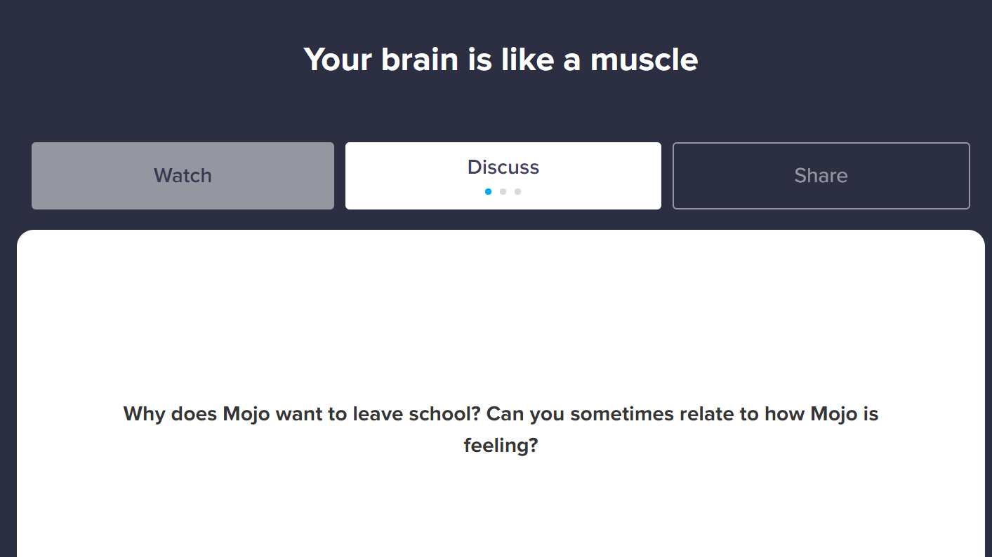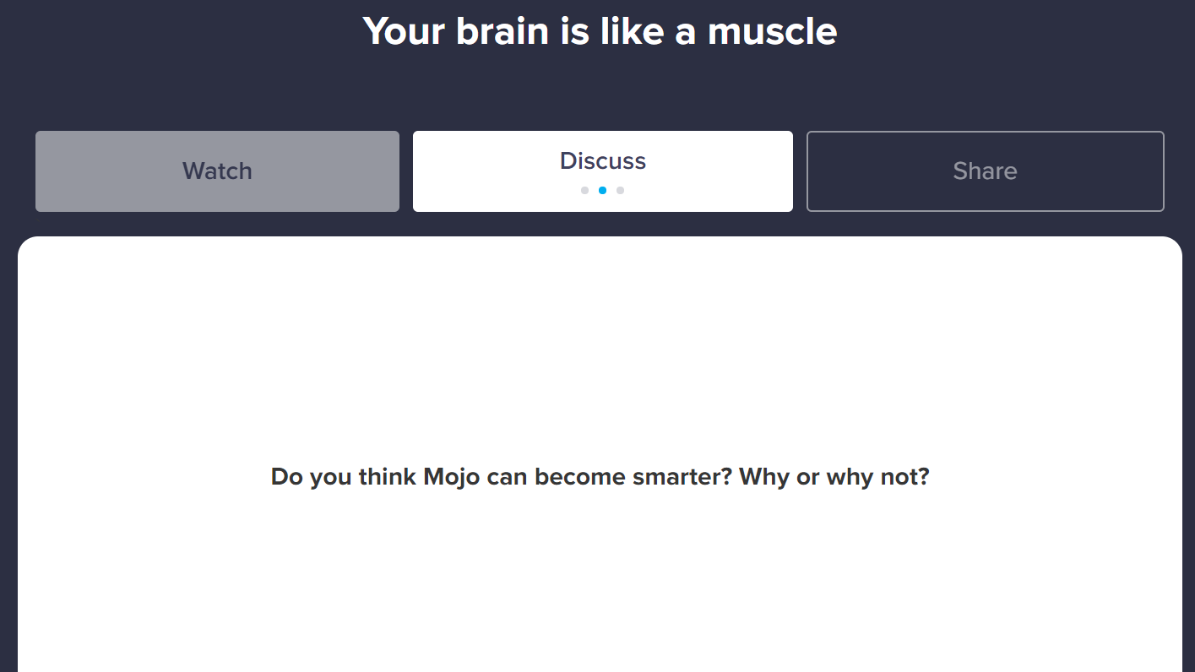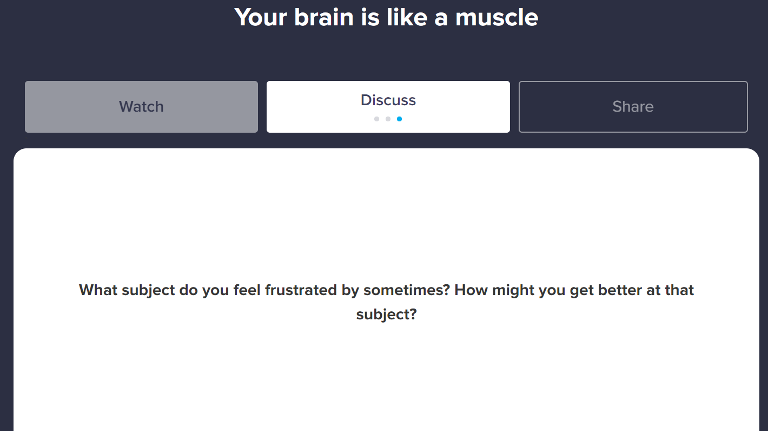

Tuesday’s Resources
Tuesday’s English
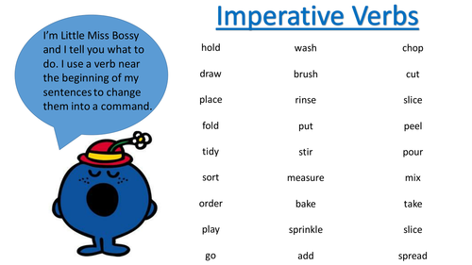

Tuesday’s Maths: Length Recording Grid

What are you measuring with? ____________________

 | Object being Measured | Estimate/Guess - (How many __________ do you think it will measure?) | Result - (How many __________ did it actually measure?)
1.
2.
3.
4.
5.
Now the objects in order from the shortest length to the longest length:
1.
2.
3.
4.
5.

Tuesday’s SPHE: The Magic of Mistakes Questions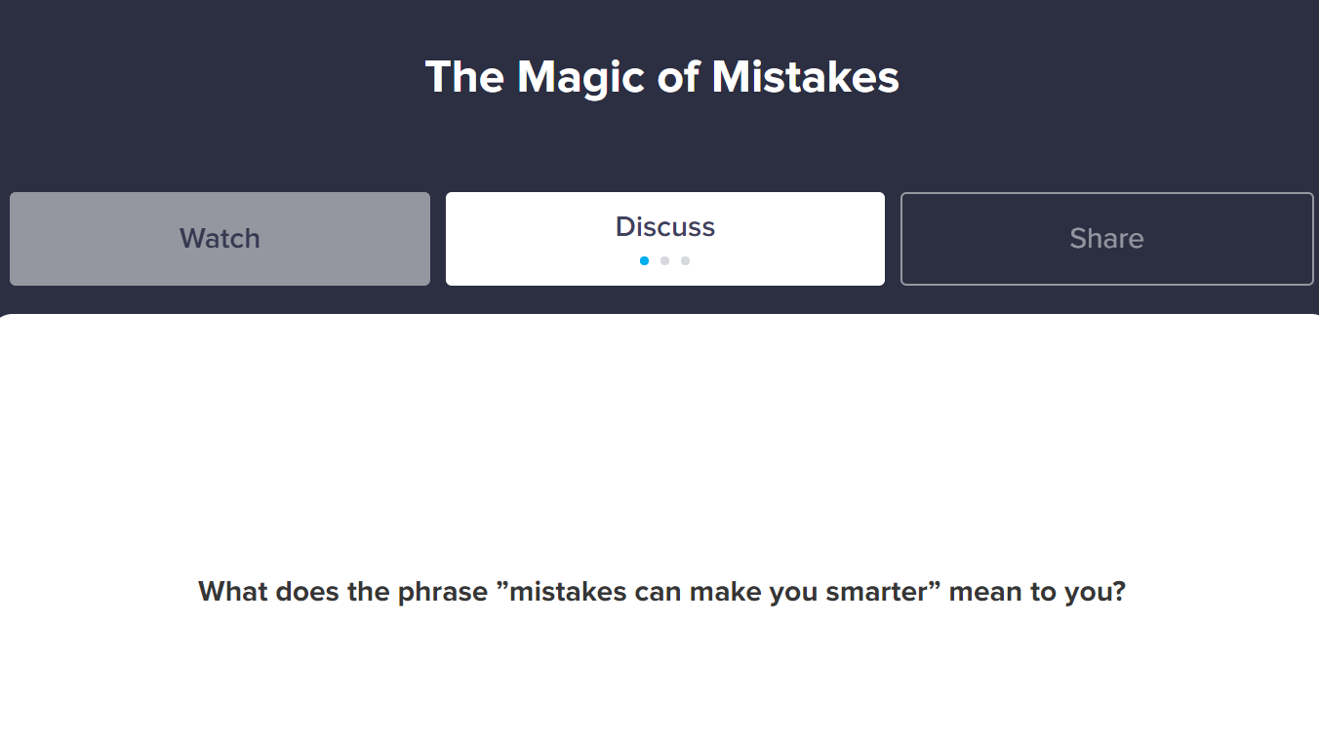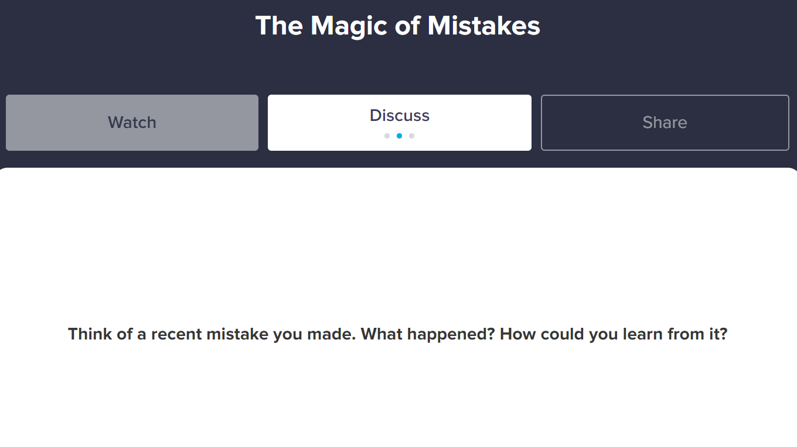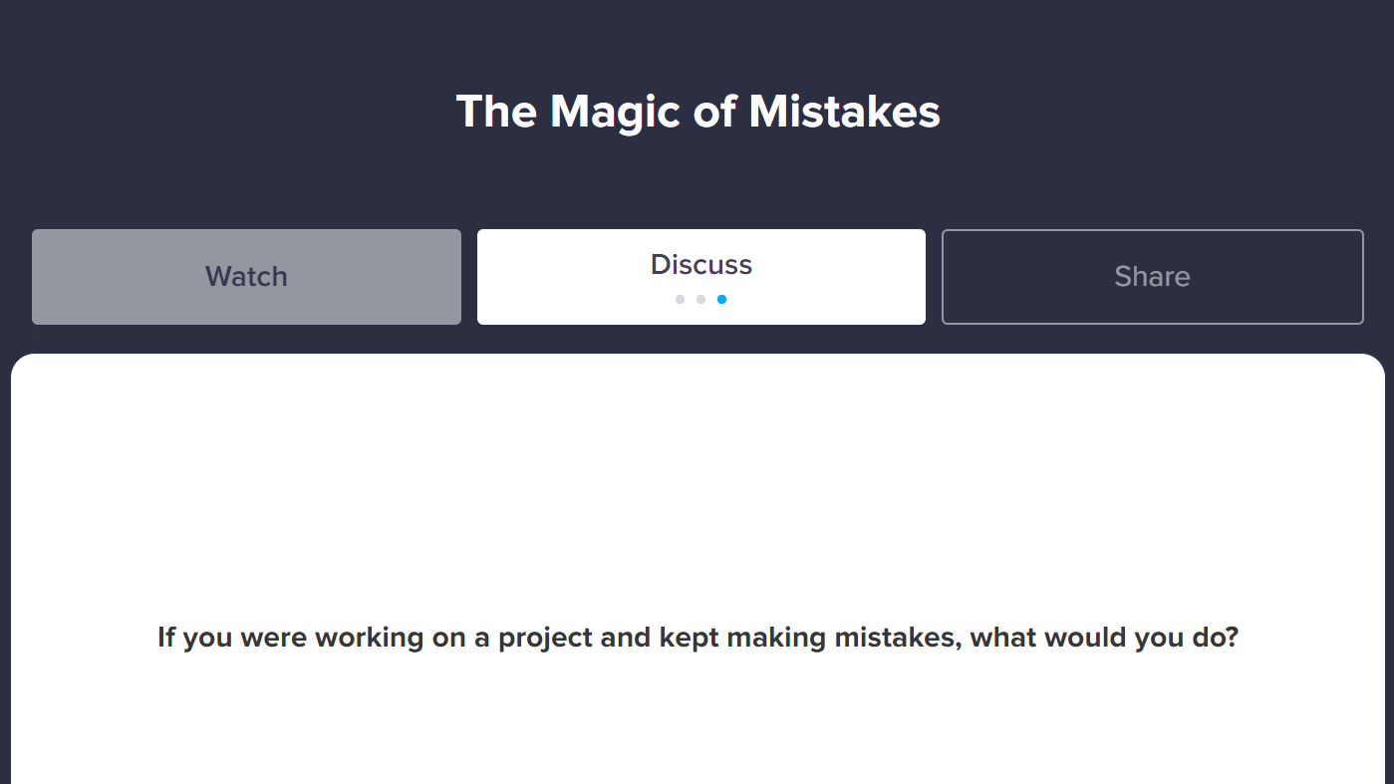

Wednesday’s Resources:

Wednesday’s English: Muddled Instructions!
Oh no! My computer has muddled up my instructions for making breakfast. Can you put these instructions into the correct order? You could number them first and then cut them up and re-stick them in the correct order, or you could just write them out correctly into your copy. Thank you for your help! :-)
Eat the cereal.
Add milk to the bowl.
Take an empty bowl.
Take a spoon.
Put some coco pops into the bowl.
Wash hands.

Wednesday’s SPHE: Questions for The Incredible Power of Yet 