Monday Plan
Daily activities:
Spellings: Learn 4 spellings each day.
Reading: Read for at least 20 minutes.
Tables: Practice your multiplication tables (focus on x7 and x8 this week)
Dán: Practice the poem ‘Bláthanna’ (Flowers). Read the poem provided, or listen to our recording of it to help you.

1. English: We are starting the week with a few short activities, just like last week. You are used to doing stations in school so this will be like that, except you don’t need to move around! You should spend approximately 10 minutes on each task.
- Task 1: Read aloud from your novel to your adult at home.
- Task 2: Cursive handwriting - complete the handwriting sheet given. You may do these sentences in your copy if you are unable to print it out. Remember to form each letter correctly. Don’t rush - take your time!
- Task 3: Practise writing out your sixteen spellings using look, cover, write, check. Look up any unfamiliar words.
- Task 4: Play some grammar games on https://www.grammar.cl/Games.htm

2. Maths:
- Take a look at this video which introduces the topic of symmetry.
- Take a look around your house and see can you find any shapes which are symmetrical. Look in the mirror - is your face symmetrical? Take a look outside - can you see anything which looks symmetrical? Make a list of 10 things you can see or find which are symmetrical.
- Look at/do p. 133 in Planet Maths.

3. Science:
- We are learning about Sound this week. Watch this video to learn a little about sound. This video explains what sound is, how it is created, and how we are able to hear different sounds.
- Listen to these sounds from around the house, and write down what you think they are: https://eslgames.com/sounds-from-around-the-home/
- Close your eyes and have someone in your home make sounds with different objects and try to guess what they are, without peeking! Then swap over, letting them guess what different sounds are.
- Read pages 48 and 49 of “Unlocking Science with Science Fusion 3rd Class” to learn about what sound is https://www.folensonline.ie/home/library/programmes/unlockingscience-3rdclass/ebook/

4. Learn Together:
Each year, classes visit various places of worship to learn a little more about a particular faith. This year, 3rd class are learning about Sikhism and the gurdwara. We can’t visit a gurdwara at the moment, but we will learn about it this week instead!
- Have a think about these two questions:
- Do I already know anything about Sikhism?
- What would I like to learn about Sikhism? You can write these down if you wish, so that in a few days, you can check and see if you learned the answers!
- Read the powerpoint about Sikhism.

Bonus activity: It’s really important to stay active while you are at home. Check out a PE lesson with The Body Coach here.
Maths:
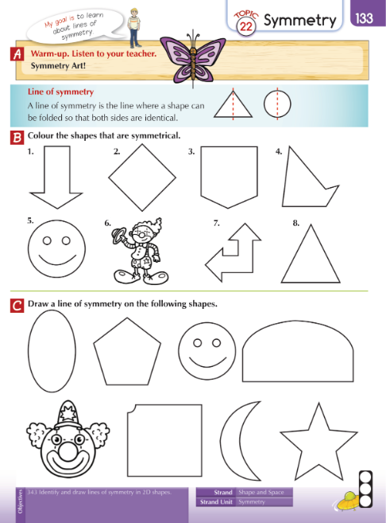

Science:
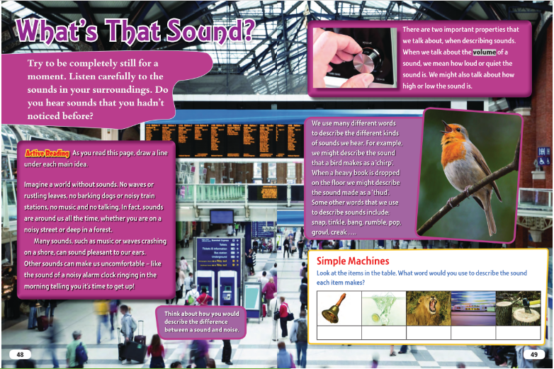
Cursive Writing:
