Monday:

Daily activities​
​Empower Tools - strengthen your focus
Spellings
Tables ÷2 ÷3
Maths - Decimals
Gaeilge - Éadaí
English - Comprehension
Empower Tools
Strengthen your Focus

1. Spellings: scant, distant, servant, important, vacant, instant.
Sentences: Put 3 of these spellings into a sentence each.

2. ​Maths:
-Revise ÷2 ÷3 tables. Click here for a game to help you revise.
-Open Planet Maths on folensonline.ie. (Screenshots added here for convenience)
- Today’s goal - add 2 decimal numbers. (Remember place value and make sure the decimal points are lined up!).
-Answer B on page 109.
- *There are extra maths worksheets for those who would like a challenge under Fridays work*
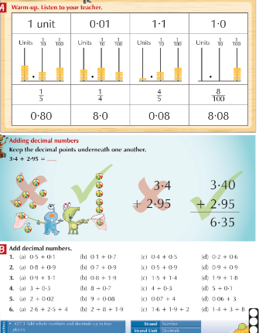

3. Gaeilge (see Gaeilge support document for translations)
- For an Irish Dictionary to help you can click here
- Look at this PowerPoint from Twinkl to revise some vocab on éadaí (clothes)
- If you can print here is a matching activity on éadaí. If you can’t print it off you could draw a picture and label different clothing items.
- Here are some word searches on éadaí too, why don't you try to make your own word search too?

Monday

The PowerPoint will give the correct answers as you go

Cófra Éadaí
Gúna – dress
Stocaí – socks
Bríste – trousers
Cóta – coat
Háta –hat
Scairf – Scarf
Carbhat – tie
Bróga – shoes
Geansaī – jumper
Léine – shirt
T-léine – t-shirt

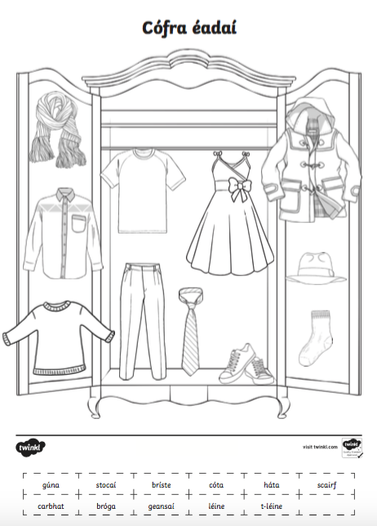

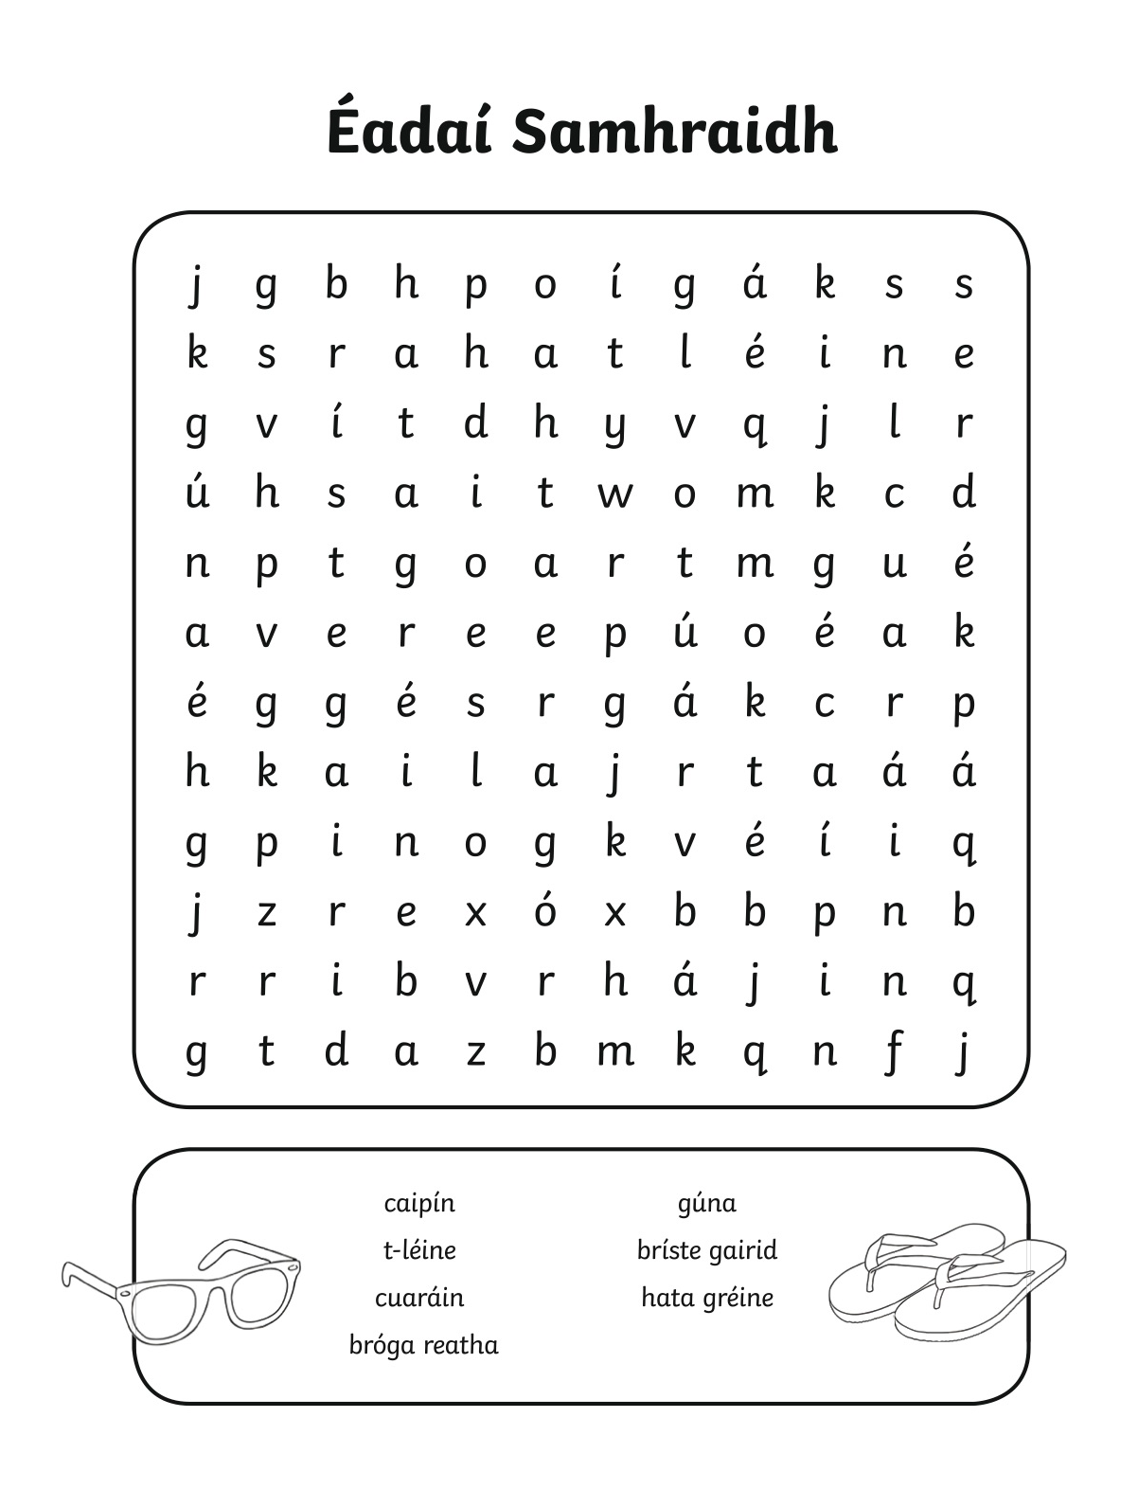

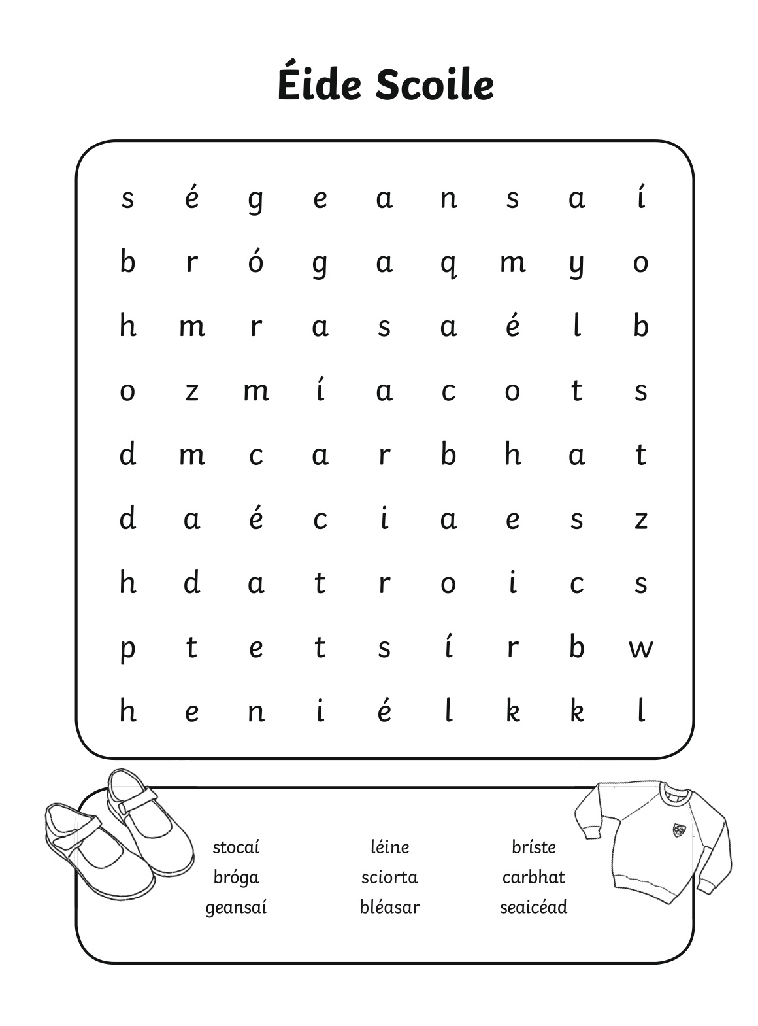

4, English - Read Why the Rhino has grey skin. Create 5 questions for the story.
