Friday Plan
Daily activities:
Spellings: Revise your spellings for this week.
Reading: Read for at least 20 minutes.
Tables: Practice your multiplication tables (focus on x7 and x8 this week)
Dán: Practice the poem ‘Bláthanna’ (Flowers). Read the poem provided, or listen to our recording of it to help you.

- English:
- This term, we will be learning about persuasive writing. A persuasive text is a text which argues a point of view, to convince the reader to agree with the author.
- Read the page: ‘Are Mobile Phones Necessary?’ You don’t need to write anything, but we want you to answer the following questions orally: What is the author trying to argue? How are they trying to convince you?
- Revise your spellings. If your adult is able to, they could test your spellings today. If not, you could create a wordsearch containing all 16 spellings, or put all 16 spellings into alphabetical order.

- Maths:
- Recap: write or draw 5 facts which you know about symmetry. You might like to create a poster all about symmetry.
- Write the alphabet in your copy and circle each letter which is symmetrical, drawing in the line(s) of symmetry.
- Look at/do p. 137 in Planet Maths.

3. Science:
Today our science lesson is about experimenting! We have three simple science experiments for you to try. Have a look at what you need for each one and then you can decide which one(s) to try! (Check back to our school website for the links)
- Try the grow a rainbow experiment
- Make a volcano - be sure to do this one outside!
- Try to make a paper hovercraft!

4. Learn Together:
- Yesterday, you learned about what democracy is. We have democracy in Ireland and our government meets at ‘Dáil Eireann’ to make decisions about our country.
- Read the ‘Dáil Eireann’ powerpoint to understand more about our government. You might remember that we had an election back in February. This means that our government will change soon but the information in the powerpoint is correct for now!
- In this video, 3rd and 4th class pupils in a school in Co. Waterford show us how people are elected to the Dáil and how our voting system works.

Bonus activity: Every Friday, we learn sign language with Caitríona at assembly. Practise with Caitríona here to keep up your sign language skills while you are at home!
This also links to our learning in Science this week. People who are deaf are unable to hear sounds, so they use sign language to communicate instead.

Don’t forget to celebrate your learning with some Golden Time - you can even get the rest of your family involved!

Maths:
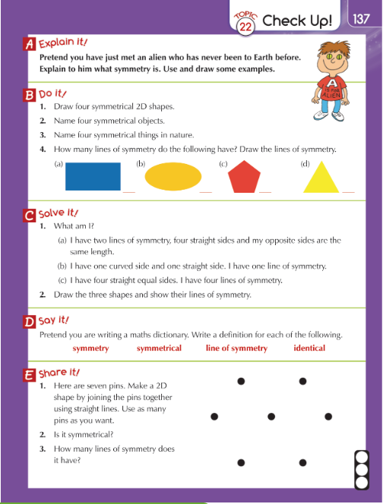

English:
