Friday Plan - 15th May 2020

Daily activities:
Spellings: Learn 4 spellings each day.
Reading: Read for at least 20 minutes.
Tables: Practice your multiplication tables (focus on x11 and x12 this week)
Gaeilge: Practice 5 questions of your choice and answer orally.
Whole-school event: Go to the Well-being Fortnight page for today’s activity!

1. English:
- Revise your spellings. If your adult is able to, they could test your spellings today. If not, you could create a wordsearch including all 16 spellings. Alternatively, you could go to Seesaw and practice typing out each word in a document.
- Reading comprehension: Today we are linking our English work with our learning in SESE for this week. Read the comprehension all about Koalas and answer questions 1-8, either on the printed sheet or in your copy.

2. Maths:
- Play ‘Division Facts’ on ‘Hit the Button’
- We covered a lot this week and we really want to make sure that you understand everything! Look back over the learning materials from this week (the Powerpoint, videos and workbook pages) and make sure that you understand it all!
- Look at / do the ‘Check Up’ in Planet Maths p. 147

3. SESE:
Today we are continuing with the project and the instructions provided yesterday. As a reminder, be sure that your project includes:
- A colourful title
- A picture/drawing of Australia
- A picture/drawing based on your topic eg. animal, city, landmark
- 10 facts about your topic (written in your own words!)
Check back to yesterday’s plan for some useful resources and websites that might help. And finally, be sure to send your project to your teacher if you can, using either Seesaw or the school website!

Bonus activity: Caitríona will be hosting an assembly for you on Zoom today. Try to join in if you can - she would love to see you! If you can’t make it, you can still practise your sign language skills with Caitríona here.

Don’t forget to celebrate your learning with some Golden Time - you can even get the rest of your family involved!

English: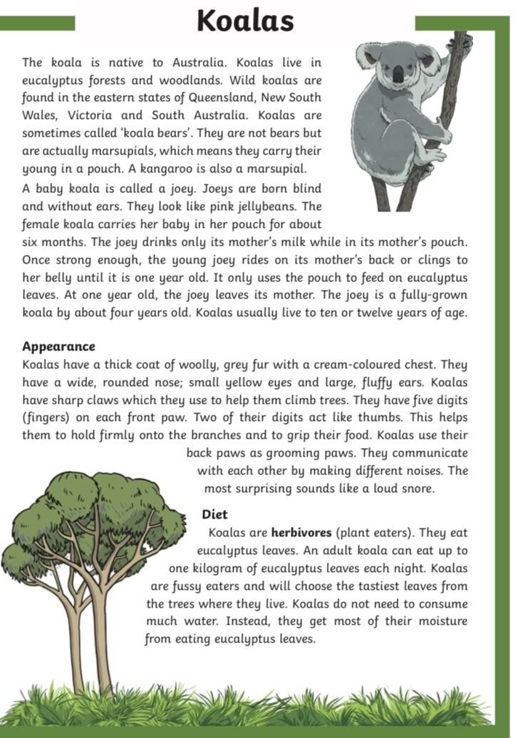
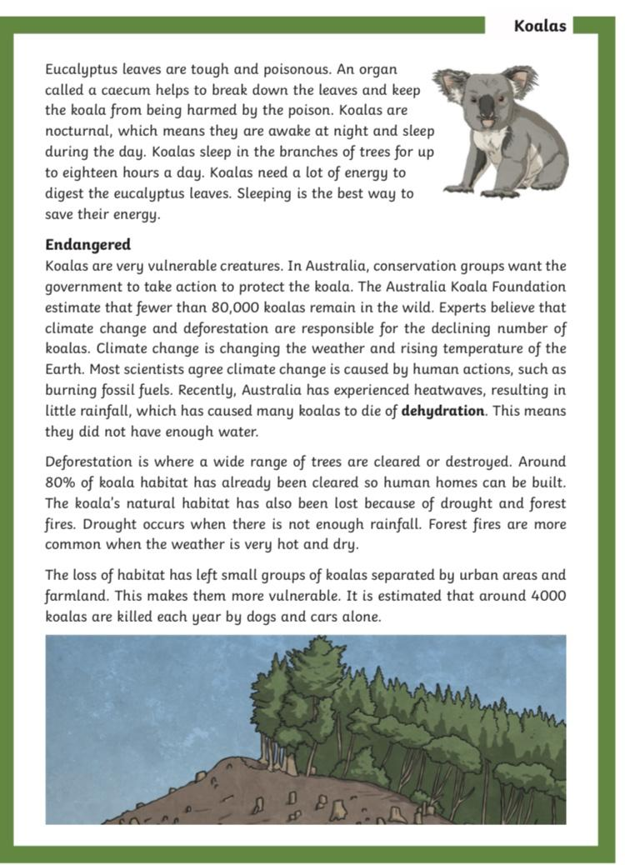

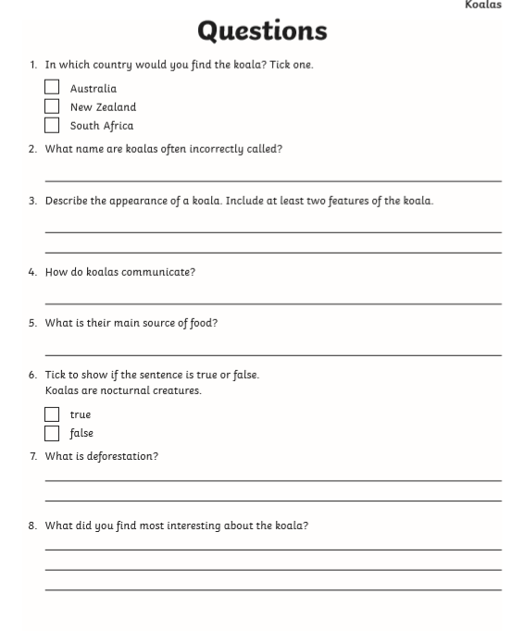

Maths:
