Friday:

Suggested Daily Schedule

Spellings: Practice your spellings each day
Maths: Practice Big Maths Beat That each day
Reading: read a book for 30 mins each day
Language: complete your activity for each day (https://www.citywestetns.ie/language-fortnight.html)

Test: Test yourself on your spellings from the week. (Maybe 10 spellings and 10-15 sums). If you don’t have anyone to help you could test yourself - or why not make a wordsearch or crossword with all of your spellings!
Test yourself on Big Maths Beat that too, see if you can beat your score from Monday!

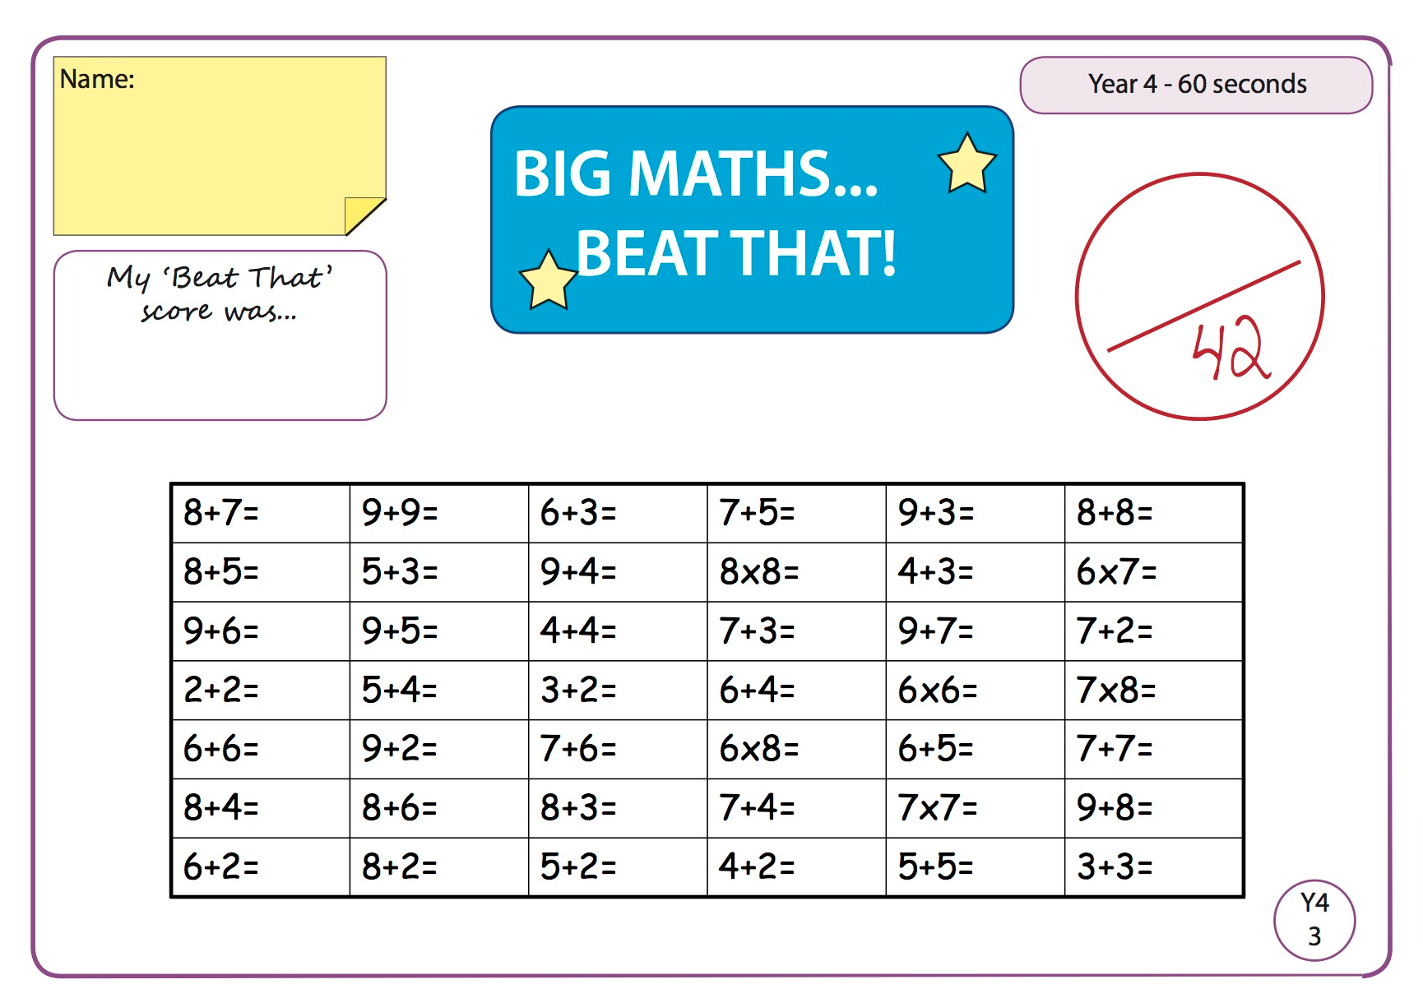

Maths:
Answer the below word problems on perimeter.

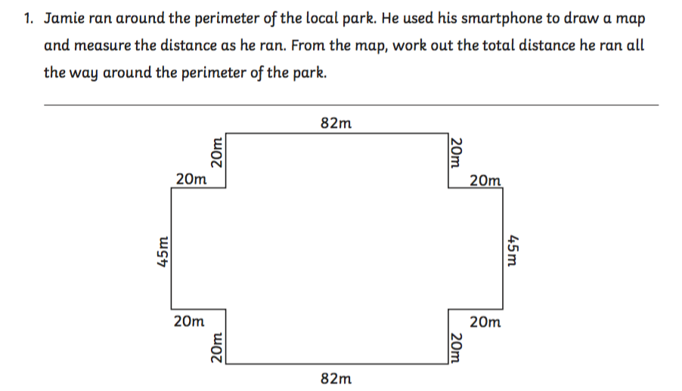

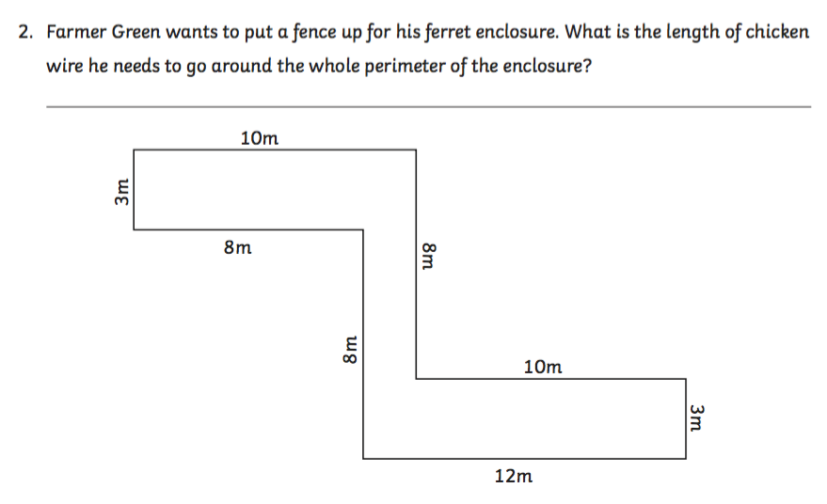

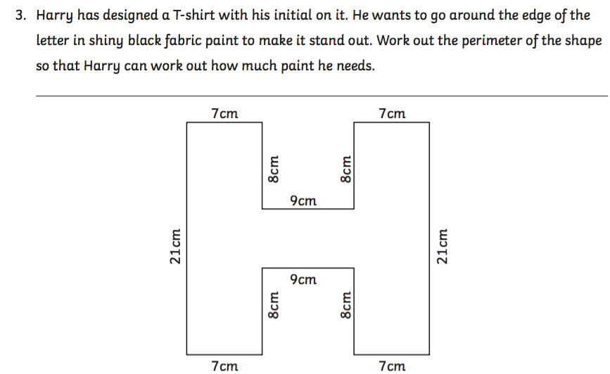

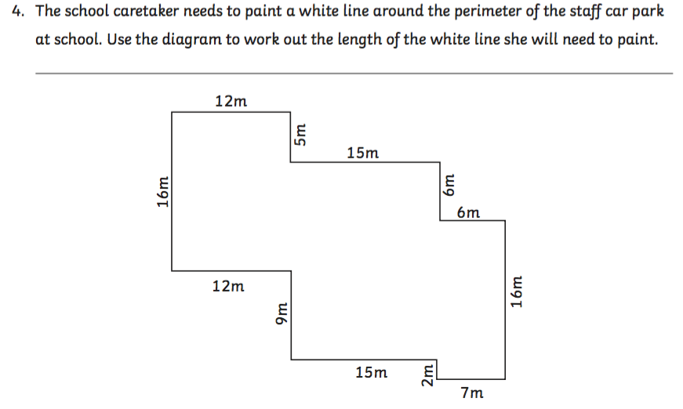

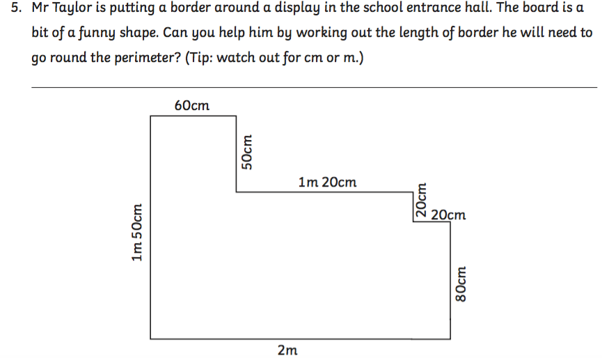

English
1.Record yourself reading with expression (reading activity on seesaw)

2. Reading the comprehension linked on the homepage and answer the questions- An Irish Summer

Gaeilge
Cad a cheapann tú den chluiche nua?. Tá físeán ann chun cabhrú leat. (What do you think about the new game?. There is a video to help you)

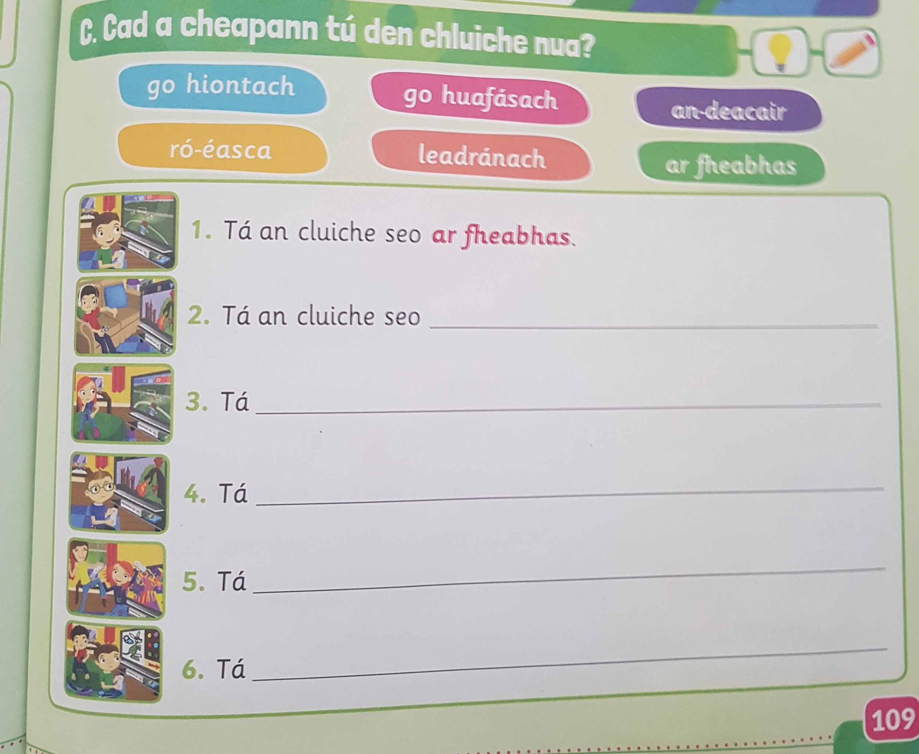

Scríobh an abairt mar is ceart. Tá físeán ann chun cabhrú leat. (Write out the sentences correctly. There is a video to help you)

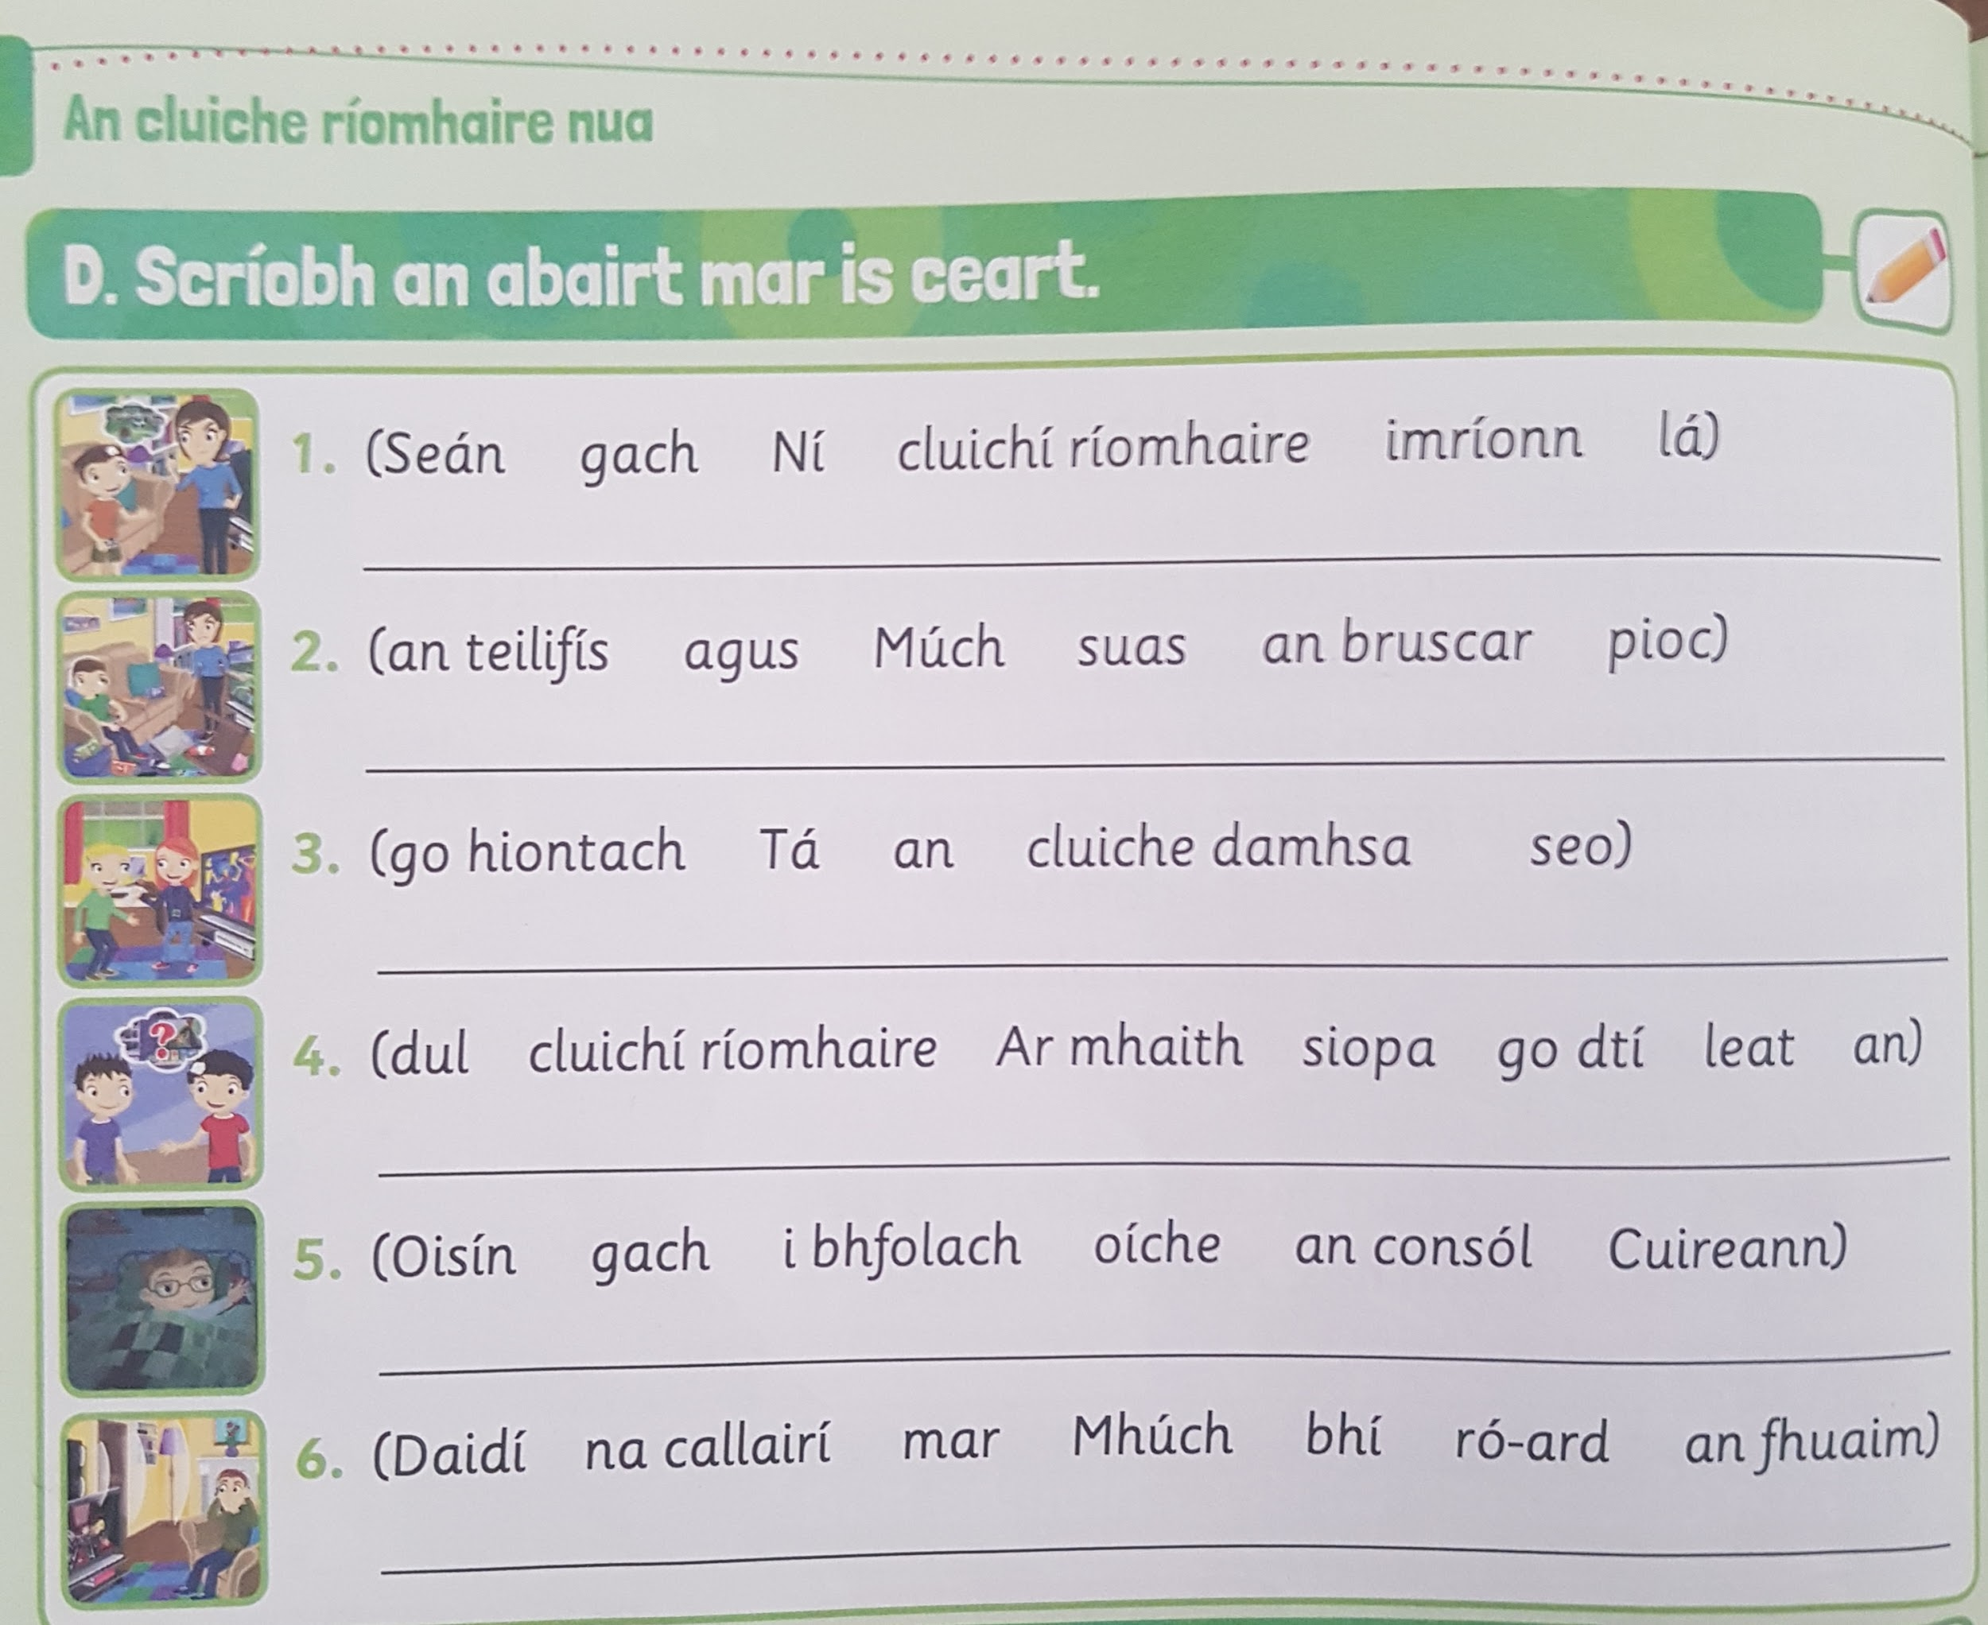

Language Fortnight
Complete activity for today

