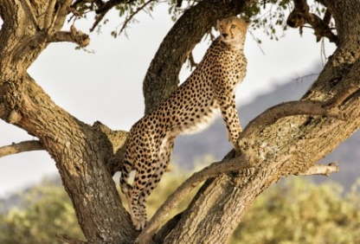
Amazing Facts About the Cheetah
Cheetahs are classified as vulnerable by the IUCN Red List of Threatened Species. With around 10,000–12,000 individuals left in the wild, cheetahs are Africa’s most endangered big cat.
Historically, cheetahs have been hunted for their fur, but today some of the biggest threats to their survival are loss of habitat, and competition for resources. Cheetahs require large areas of land for survival, so increased human settlements and road construction in their habitat puts them at risk.
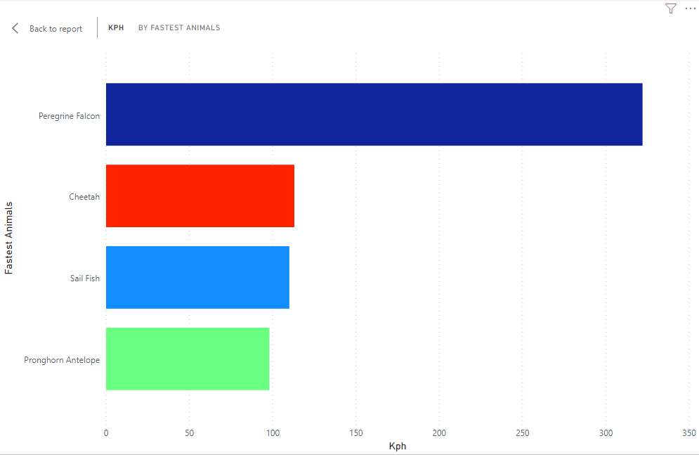
Built for speed, cheetahs are slender, with long thin legs and a long tail. Cheetahs long muscular tails have a flat shape that is used for balance and steering. The tail essentially acts like a rudder on a boat. They have coarse, short fur that is yellowish tan in colour and covered in solid black spots. Black tear-shaped streaks on the face help to reflect the sun when hunting. Adults weigh around 46–158 lb (21–72 kg). Cheetah is the fastest land predator in the world, reaching speeds of up to 113km/h. They can accelerate from 0 to 100km/h in just 3 seconds. However, the fastest fish is Sail fish, fastest bird is Peregrine Falcon (the fastest in the world), fastest herbivore (land animal that eat plants) Pronghorn Antelope.

What do cheetahs eat?
Cheetahs are carnivores, so rely on meat for survival. Their diet is made up primarily of smaller antelopes including springbok, steenbok, Thomson’s gazelle, impalas, and duiker. Cheetahs will also feed on wildebeest calves and, occasionally, smaller animals including rabbits, hares and birds.
Cheetahs have evolved to live in an environment where water is scarce and can survive on one drink every three to four days.
How many spots do cheetahs have?
Cheetahs have between 2,000 and 3,000 spots, which help them to camouflage themselves.
Where do cheetahs live?
Previously, cheetahs were widespread across African and Asian continents, but now they are confined mostly to dry open grasslands of Sub-Saharan Africa, with the majority inhabiting natural reserves or parks.
Female cheetahs are solitary, living alone or with their young. Female cheetahs spend a long time caring for their cubs and teaching them essential survival skills like hunting. Cubs typically stay with their mothers for one and a half to two years. Males however, live in small family groups of 2–3 brothers, known as coalitions.

References
https://onekindplanet.org/animal/cheetah/

